Dear Parent/Carer,
REGISTRATION FORM FOR FREE SCHOOL MEAL (FSM) ELIGIBILITY
Families who receive certain benefits may be eligible for free school meals. This is separate to the Universal Free School Meals initiative being introduced by the Mayor of London, Sadiq Khan.
Your child is eligible for free school meals if you are in receipt of one of the following benefits:
- Universal credit with an annual net earned income of no more than £7,400 (after tax and not including any benefits you get)
- Income Support
- Income based Jobseeker’s Allowance
- Income-related Employment and Support Allowance
- Support under Part 6 of the Immigration and Asylum Act 1999
- The guaranteed element of State Pension credit
- Working Tax Credit run-on (paid for the four weeks after you stop qualifying for Working Tax Credit)
- Child Tax Credit (with no Working Tax Credit) with an annual income of no more than £16,190.

This additional money is available from central government for every child whose parent/carer is receiving one of the benefits listed above. Children receive the FSM benefit directly, instead of through a parent or carer.
If you are in receipt of any of the above benefits, please do apply for free school meals, as this will generate additional funding for our school. Registering for free meals could also raise an extra £1,400 for the school.
If you think your child is eligible for Free School Meals please do not hesitate to contact myself, the School Business Manager, in confidence. You can also visit the free school meal website: https://www.gov.uk/apply-free-school-meals or alternatively you can register for FSM via the following website www.kingston.gov.uk.
If your child is eligible for free school meals, they will remain eligible until they finish the phase of schooling (primary or secondary) they are in on 31st March 2024.
Yours sincerely,
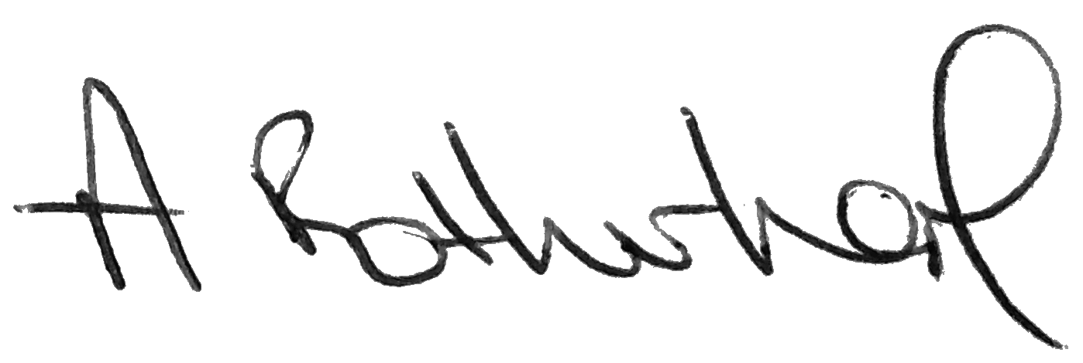
Mrs A Rotherham
School Business Manager

